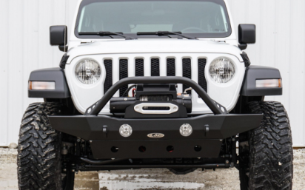
LOD Destroyer Mid Width - $669
68 lbs (bumper only, not including skid plate or bull bar)
fog lights: Y factory
Shackles: Y
Winch: sits on top
Bull bar: Y
material and thickness: -Stronger high strength/ light weight military grade steel
Notes: License plate holder and skid plate available
https://lodoffroad.com/products/jeep/2018-jeep-jl-products/front-bumpers/2018-jl-destroyer-mid-width-front-bumper.html

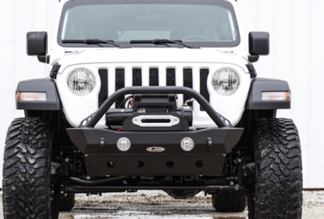
LOD Destroyer Shorty - $669
58 lbs (bumper only, not including skid plate or bull bar)
fog lights: Y factory
Shackles: Y
Winch: sits on top
Bull bar: Y
material and thickness: -Stronger high strength/ light weight military grade steel
Notes: License plate holder and skid plate available
https://lodoffroad.com/products/jeep/2018-jeep-jl-products/front-bumpers/2018-jeep-jl-destroyer-front-bumper.html

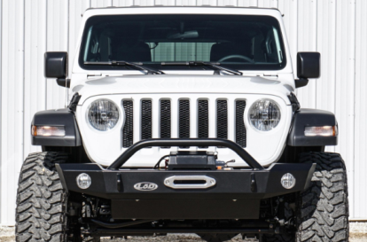
LOD Signature Series Mid Width
72 lbs (bumper only, not including skid plate or bull bar)
fog lights: Y factory
Shackles: Y
Winch: protected inside bumper
Bull bar: Y
material and thickness: 3/16" steel
Notes: skid plate available, license plate???
https://lodoffroad.com/products/jeep/2018-jeep-jl-products/front-bumpers/2018-jl-signature-series-mid-width-new.html

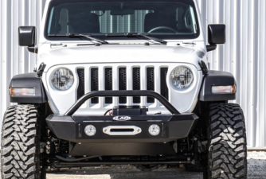
LOD Signature Series Shorty
https://lodoffroad.com/products/jeep/2018-jeep-jl-products/front-bumpers/2018-jl-jeep-signature-series-shorty-new.html

Metalcloak - Frame Build Bumper - $857 - mid - width with end caps
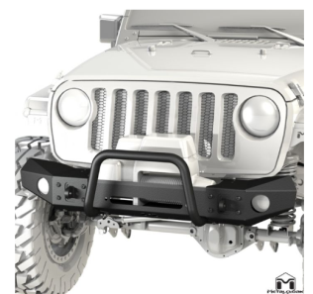
weight: 80lbs, includes caps, winch plate, and bull bar
fog lights: Y factory
Shackles: Y
Winch: protected inside bumper
Bull bar: Y
material and thickness: 3/16" steel
Notes: skid plate available, license plate available

https://metalcloak.com/jeep-jl-wrangler-suspension-fenders-skid-plates/jl-wrangler-bumpers/frame-built-bumper-2401-jl-wrangler.html

Roam - Pioneer Front Bumper (Aluminum) - $499
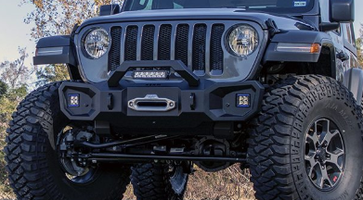
weight: 100lbs
fog lights: Y factory?
Shackles: Y
Winch: protected inside bumper
Bull bar: Y
material and thickness: 7050 T-74 aluminum construction
Notes: skid plate available, license plate available
http://www.roamoffroad.com/product/roam-jl-pioneer-front-bumper-jeep-wrangler-jl/

poison spider - JL Crawler Front Bumper w/Crawler Skid & Winch - $769
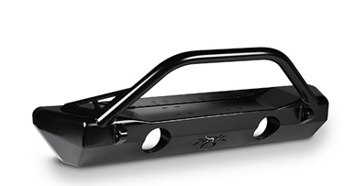
weight: ?
fog lights: Y factory
Shackles: Y
Winch: sits on top
Bull bar: Y
material and thickness: 3/16" plate steel
Notes: skid plate available
license plate available?
http://shop.poisonspyder.com/JL-Crawler-Front-Bumper-p/19-58-010dbp1.htm

poison spider - bruizer - $799
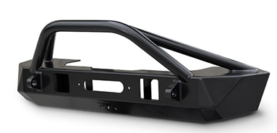
weight: ?
fog lights: N
Shackles: Y
Winch: sits on top
Bull bar: Y
material and thickness: 3/16" plate steel
Notes: skid plate available
license plate available?
http://shop.poisonspyder.com/JL-Bruizer-Front-Bumper-p/19-57-010dbtp1.htm

Rigged Ridge XHD aluminum bumper

smittybilt 76806 xrc Gen2 front bumper
Smittybilt 76730 Stryker Front Bumper
*Smittybilt 77807 XRC Gen2
rough country front stubby LED winch bumper - chrome series

rockhard 4x4 https://www.rockhard4x4.com/product_p/rh-90216.htm

ARB Bondi
Motobilt JL Front Bumper w/stinger/skid - the hammer series
Quadratec QRC Stubby Front Winch Ready Bumper
JRC Offroad Crusader
artec industries
Rough country LED winch bumper
Quadratec QRC stubby front winch ready bumper
Hawk - https://haukoffroad.com/bumpers/jl-front-bumper/
moto bilt JEEP JL FRONT BUMPER W/STINGER/SKID PLATE 18+ WRANGLER JL THE HAMMER SERIES

Rugged Ridge 11549.04 Arcus Stubby Front Bumper with Winch Mount and Tow Hooks for 18-19 Jeep Wrangler JL & 2020 Gladiator JT

Spartan Bumper, Standard Ends, Overrider; 18-19 Wrangler/Gladiator

Nemesis - https://www.nem-ind.com/products/jeep-wrangler-jk-accessories/bumpers/odyssey-front-bumper.html

DV8https://www.quadratec.com/p/dv8-offroad/fs-15-hammer-front-stubby-bumper-jeep-wrangler-jk-and-jl?utm_source=criteo&utm_medium=display&utm_campaign=retargeting&utm_content=lower-funnel

Barricade Adventure HD

Expedition 1 - http://www.exp-one.com/products/jl-wrangler-front-bumpers/

lift kit https://www.ebay.com/itm/Jeep-Gladiator-JLT-2-5-Lift-Leveling-Kit-2020/254219385345?fits=Model%3AGladiator&hash=item3b30a7fa01:g:i7AAAOSwhmNczIHN

did not like bumper, but maybe rock rails/sliders https://genright.com/products/jeep-jl-2018-4-door-rocker-guards-steel.html

shackles for OEM bumper, must remove air dam/skid plate :( https://www.quadratec.com/p/warn/recovery-points-jeep-wrangler-jl-factory-rubicon-steel-front-bumper
shackles for the JK https://www.frogfab.com/jk/jk-oem-front-bumper-clevis

https://www.rubitrux.com/maximus-3-jl-steel-bumper-group-red-d-ring-loops-max3-jl1022br.html

sliders https://www.frogfab.com/jl/rock-sliders
JCR Sliders

maximus 3 JL stealth front license plate bracket and frame

floor mats https://www.jeepgladiatorforum.com/forum/threads/slush-mats.17078/#post-253316

mud flaps https://rokblokz.com/collections/jeep-mud-flaps?https://rokblokz.com/products/jeep-wrangler-jl-jlu-2018-mud-flaps&gclid=EAIaIQobChMI4_iX-rfm4gIVAdtkCh0JpQVZEAAYASAAEgJ1UvD_BwE

