Wheels - ensure they work with factory TPMS (tire pressure monitoring sensors)
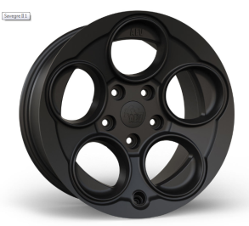
JL Savegre II by AEV - $260
size 17*8.5
backspacing: 5.77
Offset: +25mm
Centric?
Weight : 33 lbs
Max Load Rating: 2400 lbs

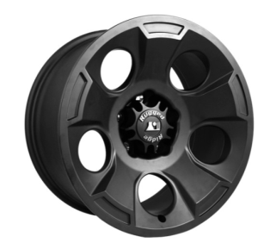
Rugged Ridge Drakon – Black Satin $333.28 $299.99 on amazon $299 on Quadratec
Size: 17*9
Backspacing: 4.53
Hub-centric
Max Load Rating: 2200 lbs
Weight: 26 lbs
Offset: -12mm
https://ruggedridge.com/drakon-wheel-17x9-black-satin-w-center-cap-15302-01.html
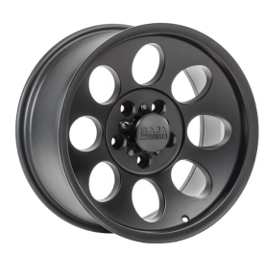
Quadratec Baja Xtreme II in Satin Black #139.99
Size: 17*9
4.75in backspace (-6 offset)
Weight: 29 lbs
Max Load Rating: 2100 lbs
Hub Centric
https://www.quadratec.com/p/quadratec/baja-xtreme-jeep-wrangler-jk-and-grand-cherokee-wj-wk-wk2
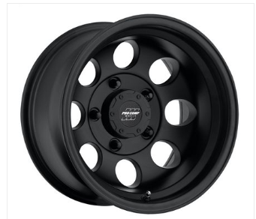
Pro Comp 69 Series Vintage Wheel - flat black $110.99
Size: 17*9
Back space: 4.75
Offset: -6
weight: 24lbs
Max load rating: 2200 lbs
Lug Centric :(
https://www.4wheelparts.com/p/pro-comp-69-series-vintage-wheel-17x9-with-5-on-5-bolt-pattern-flat-black-7069-7973/_/R-BKBQ-7069-7973

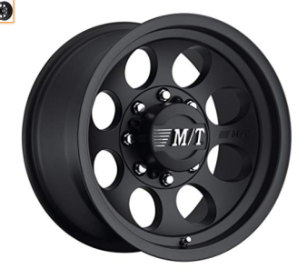
Mickey Thompson Classic III Black (matte) Wheels - $148.99
size: 17*9
backspace: 4.5
offset: -12.00mm
weight: 27 lbs
Max load rating: 2,500 lbs
centric??
https://www.mickeythompsontires.com/wheels/classic-iii-black
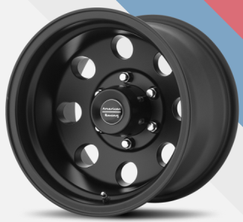
American Racing AR172 BAJA - Satin Black $149 at performanceplustire.com
size: 17*9
backspace: 4.53
offset: -12mm
weight: 26.42 lbs
max load: 2500
Centric?
https://www.americanracing.com/product/wheels/ar172-baja/?attribute_pa_finish=satin-black

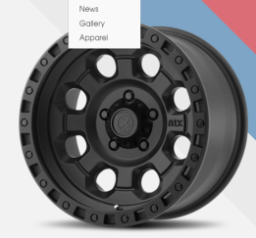
American Racing AX201 - Cast Iron Black
size: 17*9
backspacing: 4.53
offset: -12mm
weight: 31.42 lbs
max load: 2500
Centric?
https://www.americanracing.com/product/wheels/ax201/?attribute_pa_finish=cast-iron-black

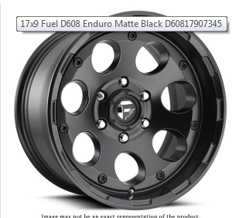
Fuel D608 Enduro Matte Black - $215 - D60817907345
size 17*9
backspacing: ?
offset: -12
weight: 28 lbs
Max Load: 2500 lbs
Centric: ??
https://rimzoneonline.com/17x9-fuel-d608-enduro-matte-black-d60817907345.html

Per AEV they are not the same:
JK Borah: https://www.aev-conversions.com/product/jk-borah/#color
Size: 17" x 8.5"
Bolt Pattern: 5x5
Offset: +4mm
Approximate Backspacing: 4.9"
JL Borah: https://www.aev-conversions.com/product/jl-borah/#color
Size: 17" x 8.5"
Bolt Pattern: 5x5
Offset: +25mm
Approximate Backspacing: 5.72"
Wrangler wheels are all 7.5" width with +44.45 offset (6.1" backspace). The lone exception is the base Sport steel wheels found on rare models.

We assume the Gladiator wheels will be the same specs, though there is some info out there that states that Gladiator wheels will have greater load capacity to handle the hauling/towing needs. This could mean those wheels end up being heavier.

With aftermarket wheels, the ideal spec is 8.5" width and 5.0" backspace. This gives appropriate width for any tire from a 10.50 width to 12.50 width, and it gives just enough clearance to avoid rubbing on suspension components and body trim. This is just the ideal spec...you can tweak it a little and go 4.5" backspace, or 9" width, etc.

Stock JK Rim? Also you can see in the pic of the stock rim on the scale; 25lbs, 17x7.5 size and 44.45 offset.

Here is the spec for their JK wheel
upload_2019-2-25_8-47-26.png

And here for the JL.

upload_2019-2-25_8-48-5.png

